Roll no : 59,48

**Practical 5**

package demo

import java.io.FileReader;

import java.io.IOException;

import java.util.concurrent.TimeUnit;

import org.openqa.selenium.By;

import org.openqa.selenium.WebDriver;

importorg.openqa.selenium.firefox.FirefoxDrivr;

import org.testng.annotations.BeforeTest;

import org.testng.annotations.Test;

import com.opencsv.CSVReader;

public class demo2_6

{

String CSV_PATH="D:\\TYCS\\selenium settings\\data1.csv";

WebDriver driver;

@BeforeTest

public void setup() throws Exception {

System.setProperty("webdriver.gecko.driver", "D:\\TYCS\\selenium settings\\geckodriver.exe");

//WebDriver driver = new FirefoxDriver();

driver = new FirefoxDriver();

driver.manage().window().maximize();

driver.manage().timeouts().implicitlyWait(15, TimeUnit.SECONDS);

driver.get("file:D:/TYCS/selenium settings/data.html");

}

@Test

public void csvDataRead() throws IOException{

CSVReader reader = new CSVReader(new FileReader(CSV_PATH));

String [] csvCell;

//while loop will be executed till the last line In CSV.

while ((csvCell = reader.readNext()) != null) {

String FName = csvCell[0];

String LName = csvCell[1];

String Email = csvCell[2];

String Mob = csvCell[3];

String company = csvCell[4];

driver.findElement(By.xpath("//input[@name='FirstName']")).sendKeys(FName); driver.findElement(By.xpath("//input[@name='LastName']")).sendKeys(LName); driver.findElement(By.xpath("//input[@name='EmailID']")).sendKeys(Email); driver.findElement(By.xpath("//input[@name='MobNo']")).sendKeys(Mob); driver.findElement(By.xpath("//input[@name='Company']")).sendKeys(company); driver.findElement(By.xpath("//input[@value='Submit']")).click();

// driver.switchTo().alert().accept();

reader.close();

}

}

**Html code**

<html>

<body>

<form>

fname:

<input type="text">

<br> lname:

<input type="text">

<br> email:

<input type="email">

<br>mobile:

<input type="text">

<br>company:

<input type="text">

<br>

<input type="checkbox" name="vehicle" value="Bike" > I have a bike<br>

<input type="checkbox" name="vehicle" value="Car" checked="checked"> I have a car<br>

<input type="radio" name="gender" value="male"> Male<br>

<input type="radio" name="gender" value="female"> Female<br>

<input type="radio" name="gender" value="other"> Other<br>

<select id = "car">

<option value="volvo">Volvo</option>

<option value="saab">Saab</option>

<option value="mercedes">Mercedes</option>

<option value="audi">Audi</option>

</select>

<input type="submit" value="submit">

</form>

</body>

</html>

Output:

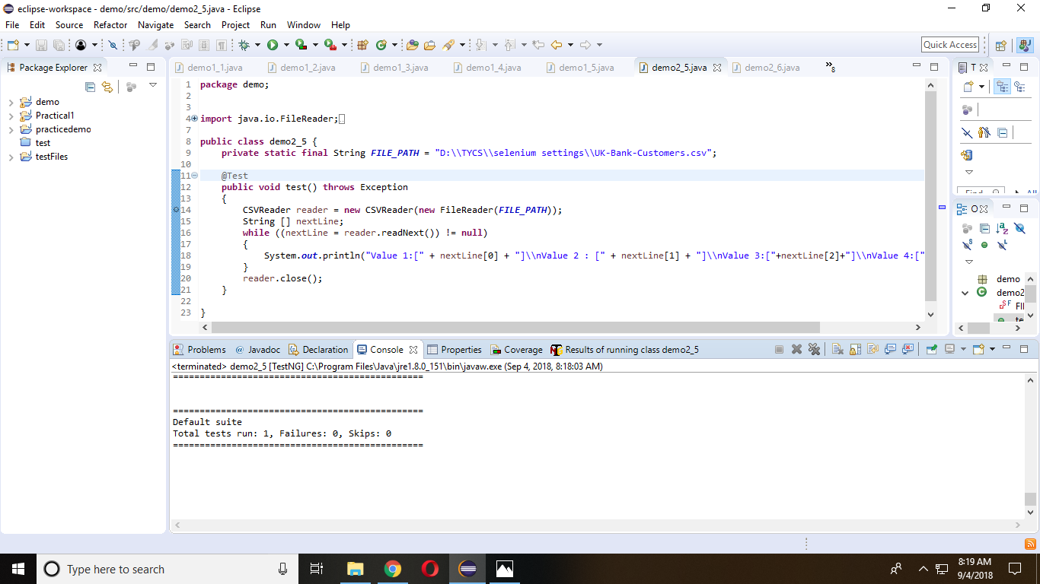

**Practical 8**

package demo;

import java.util.List;

import org.openqa.selenium.By;

import org.openqa.selenium.WebDriver;

import org.openqa.selenium.WebElement;

import org.openqa.selenium.firefox.FirefoxDriver;

import org.openqa.selenium.support.ui.Select;

public class demo2_9 {

public static void main(String[] args) {

//Define the Webdriver for Browser i.e. Firefox

System.setProperty("webdriver.gecko.driver", "D:\\TYCS\\selenium settings\\geckodriver.exe");

WebDriver driver = new FirefoxDriver();

Roll no : 59,48

//Open the URL (Website)

driver.get("file:///D:/TYCS/selenium%20settings/data.html");

//Assign and Select the dropdown list element

Select oSelect = new Select(driver.findElement(By.id("car")));

oSelect.selectByVisibleText("Audi");

List<WebElement> oSize = oSelect.getOptions();

int dropdownCount = oSize.size();

//Print the total count of dropdown list using integer variable

System.out.println("Total Number of item count in dropdown list = " + dropdownCount);

}}

Output:

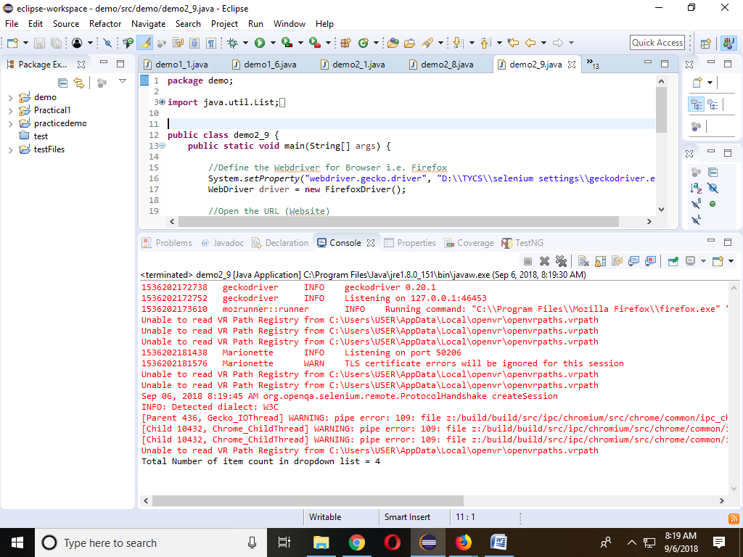

**Practical 9**

package demo;

import java.util.List;

import java.util.concurrent.TimeUnit;

import org.openqa.selenium.By;

import org.openqa.selenium.WebDriver;

import org.openqa.selenium.WebElement;

import org.openqa.selenium.firefox.FirefoxDriver;

public class demo2_8 {

public static void main(String[] args) {

System.setProperty("webdriver.gecko.driver", "D:\\TYCS\\selenium settings\\geckodriver.exe");

WebDriver driver = new FirefoxDriver();

driver.manage().timeouts().implicitlyWait(10, TimeUnit.SECONDS);

driver.get("file:///D:/TYCS/selenium%20settings/data.html");

List<WebElement> checkBoxes = driver.findElements((By.name("vehicle")));

Roll no : 59,48

for(int i=0; i<checkBoxes.size(); i=i+1){checkBoxes.get(i).click();

}

int checkedCount=0, uncheckedCount=0;

for(int i=0; i<checkBoxes.size(); i++)

{

System.out.println(i+" checkbox is selected "+checkBoxes.get(i).isSelected());

if(checkBoxes.get(i).isSelected())

{

checkedCount++;

}else

{

uncheckedCount++;

}

}

System.out.println("number of selected checkbox: "+checkedCount);

System.out.println("number of unselected checkbox: "+uncheckedCount);

}}

Output :

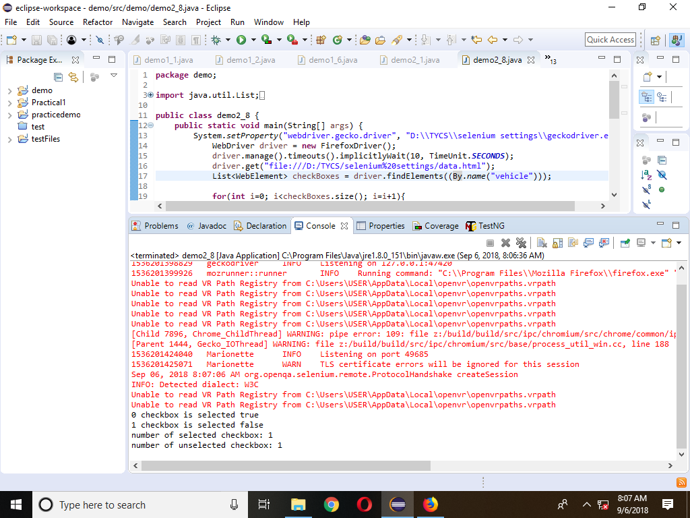

**Practical 7** Roll no : 59,48

package demo;

import org.openqa.selenium.By;

import org.openqa.selenium.WebDriver;

import org.openqa.selenium.WebElement;

import org.openqa.selenium.firefox.FirefoxDriver;

public class demo1_6 {

public static void main(String[] args) {

// TODO Auto-generated method stub

System.setProperty("webdriver.gecko.driver", "D:\\TYCS\\selenium settings\\geckodriver.exe");

WebDriver driver1 = new FirefoxDriver();

driver1.get("https://www.amazon.com/");

java.util.List<WebElement> links = driver1.findElements(By.tagName("a"));

System.out.println(links.size());

for(int i = 1;i<links.size();i=i+1)

{

System.out.println(links.get(i).getText());

}}}

Output :

